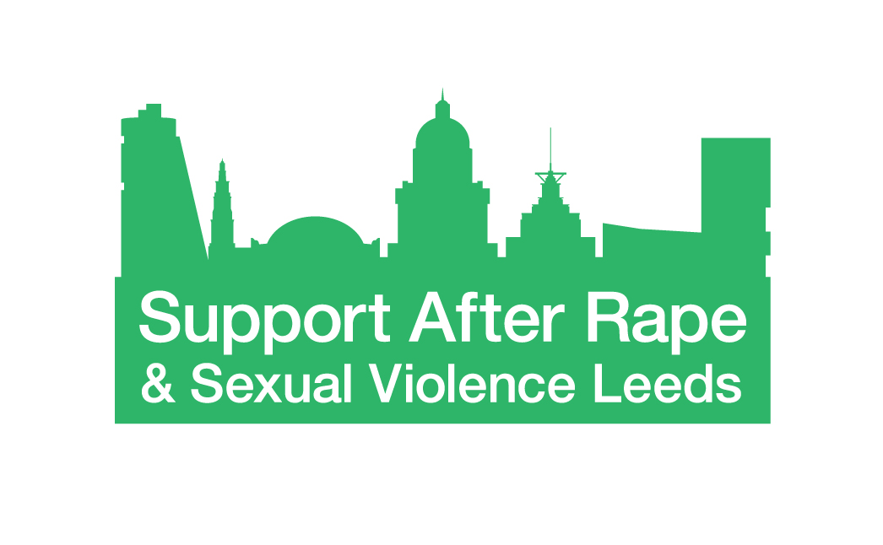
Equality and Diversity Monitoring Form

Support After Rape and Sexual Violence Leeds (SARSVL) is committed to equity and inclusion, and to actively seeking qualified candidates that contribute to the diversity of our organisation.

We ask for the following information so we can monitor and ensure our recruitment and selection processes are free from bias and discrimination. The data we are asking for reflects the Equality Act 2010.

The information you provide will be treated confidentially within our organisation. Your answers will not be used as part of the selection process. This form is detached from your application for shortlisting.

Thank you for completing this form.

Age

What is your age group?

16 – 25 26 – 35 36 – 45 46 – 55 56 – 65 66+

Prefer not to say

Disability

The Equality Act 2010 defines disability as:
“A physical or mental impairment which has a substantial and long-term adverse effect on a person's ability to carry out normal day-to-day activities.”
Do you consider yourself to be a disabled person?

Yes No Prefer not to say

Ethnicity

How would you describe your ethnicity?

Please choose one section from A to F and then tick the appropriate box.

A. White
English, Welsh, Scottish, Northern Irish, British
Irish
Gypsy or Irish Traveller
White other
B. Mixed / Multiple ethnic groups
White and Black Caribbean
White and Black African
White and Asian
Any other Mixed background
C. Asian or Asian British
Indian
Bangladeshi
Pakistani
Chinese
Any other Asian background
D. Black / African / Caribbean / Black British
Caribbean
African
Any other Black background
E. Other ethnic group
Arab
Any other ethnic background
F. Prefer not to say

Gender reassignment
Is your gender identity the same as you were assigned at birth?
Yes No Prefer not to say

Marital / Civil Partnership status
Are you married or in a civil partnership?
Yes No Prefer not to say

Religion and belief
Buddhist
Christian
Hindu
Muslim
Jewish
Sikh
Other Religion or Belief
No Religion
Prefer not to say

Sexual orientation
Please state your sexual orientation
Prefer not to say

