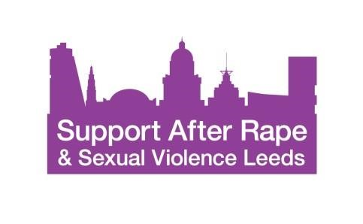
Volunteer Counsellor Person Specification
Key: ‘E’ = essential; ‘D’ = desirable

Qualifications
A Qualification in Counselling or Psychotherapy at Diploma level or successful completion of Level 4 Counselling or Psychotherapy training with extensive experience of working with clients with complex mental health needs.
Member of BACP/UKCP/NCS/BABCP or equivalent accredited member(E)
Working towards registration and accreditation with BACP/UKCP/NCS/BABCP (D)
Experience
Experience of managing clinical risk (E)
Experience of delivering a minimum of 100 hours of supervised practice with a minimum of 4 clients (E)
Experience of working with women who have experienced sexual violence (D)
Knowledge
Some knowledge and understanding of impact of trauma and trauma informed ways of working (D)
Understanding of and commitment to equality, diversity and anti- discriminatory practice (E)
Some knowledge and understanding of the impact of different kinds of sexual violence (D)
Understanding of legal and ethical responsibilities, including safeguarding and ethical framework of own governing body (E)
Skills & Attributes
Ability to manage own caseload (E)
Ability to use and seek supervision when needed (E)
Proficiency in use of Information & Communications Technology (ICT) (E)
Commitment to the vision, mission, aims and values of SARSVL (E)
Willingness to take up relevant training and development opportunities (E)

