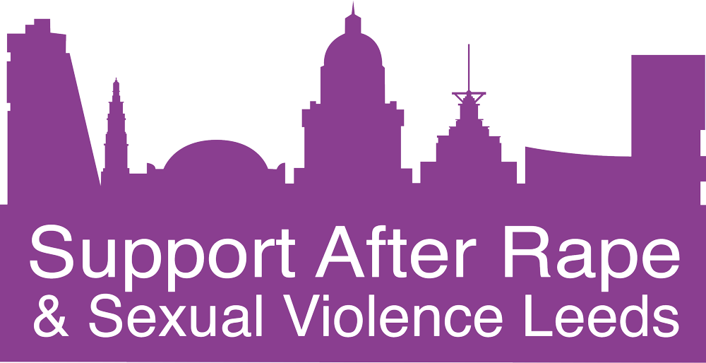
An introduction to how your ISVA can support you and information around our specialist service
SARSVL Advocacy Service Handbook

Your ISVA is …………………………………………………………..……….…………..
Her email address is ………………..………………………….……….……….……….
Her contact number is ………………………………………………….……….……….

What our service users have previously said about the ISVA service…..
This service has made this whole process a lot more manageable and it makes a difference having an ISVA to go to rather than being alone in the system. […] I honestly don’t know how you would get through without a service of this nature.

The experience with you has been brilliant and has empowered me and enabled me to talk about my trauma.

The main thing [that helped me] was knowing my rights, after years of believing I had none, I know now that I can speak up confidently if I feel I am being unfairly treated.

Contents Page Number

Introduction: About Us 4
What is Sexual Violence? 5
Our Advocacy Service 5
Referrals 6
Confidentiality 6
Our Advocacy work 7
Initial Assessment and Appointments 8
Interpreters 8
Evidential Purity 9
Note taking and record keeping 9
Self-harm and Suicide 10
Our Commitment to Service Users 11
Challenging and Abusive Behaviour 11 11
Gifts 11
Your feedback 12
FAQs 12
Our Policies 13-14
Further Reading 15
Useful Numbers 16-18

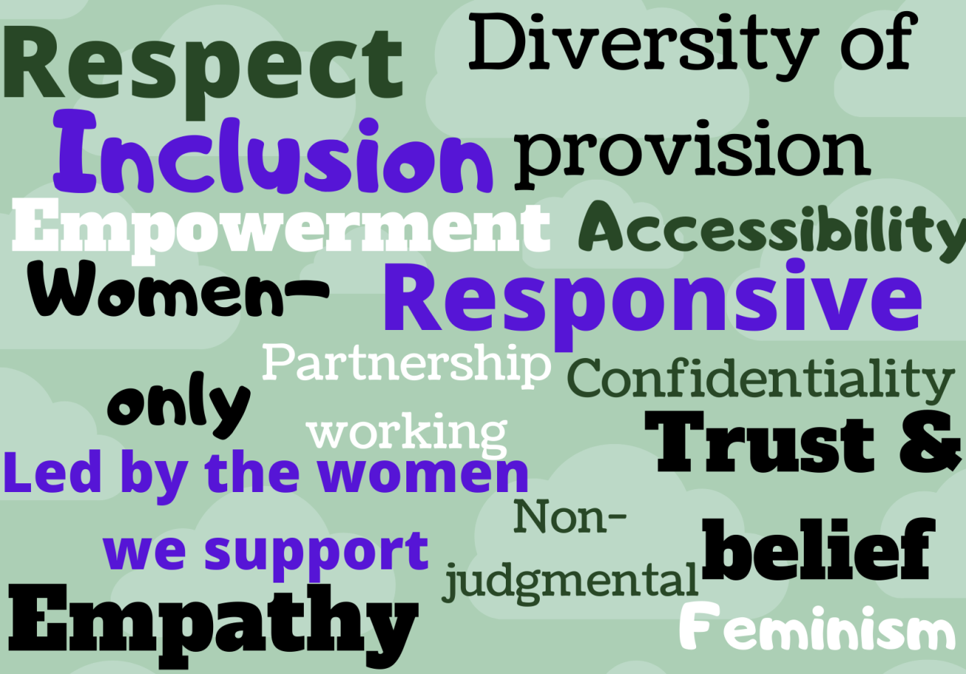
About SARSVL
We are a feminist organisation that exists to support all women and girls who have been affected by sexual violence of any kind at any time in their lives. We promote their needs and rights and work towards the elimination of sexual violence.
Our Values
Our values shape all the work we do at SARSVL, and are at the very core of our three Services.

Introduction
Support After Rape and Sexual Violence Leeds (SARSVL) is the Rape Crisis service for Leeds. We are a women only organisation offering our services to women and girls. We offer three Services – Helpline, Counselling and Advocacy. This handbook is to help you better understand our Advocacy service and the ways we can support you.

The SARSVL Advocacy Service
What is Advocacy?
Advocacy is about helping people to access information and services, and be involved in decisions about their own lives. It assists people in exploring choices and options, defending their rights and speaking out about issues that matter to them. Advocacy is about helping people have a voice and be heard.
Our Advocacy Service is an independent service working with women aged 16 and over who have been affected by rape or sexual violence at any time in their lives, and who are considering reporting or who have reported to the police.
The Advocacy Service is free and confidential and you do not need to have reported anything to the Police to access it. However, if you decide not to report to the Police we will offer you time limited support of 3 months. If you do report to the police, we can support you throughout the duration of your case. You will be allocated an Independent Sexual Violence Advocate (ISVA) who will support you throughout your time in the Service.
The Advocacy Service is constantly developing, led by what survivors tell us is helpful, and responsive to changing need. We therefore welcome your feedback about our Service.
Our ISVAs offer specialist support and advocacy to women around reporting to the Police and support throughout that process.
We will help you to:
Be heard
Take back control
Know your rights
Understand the choices and decisions in your life
We will:
Put you first
Help you to be in control
Explain issues and how they may affect you
Support you at meetings
What is sexual violence?
Sexual violence is any unwanted sexual act or activity. There are many different kinds of sexual violence, including but not restricted to: rape, sexual assault, child sexual abuse, sexual harassment, rape within marriage / relationships, forced marriage, so-called honour-based violence, female genital mutilation, trafficking, sexual exploitation, and ritual abuse.
Sexual violence can be perpetrated by a complete stranger, or by someone known and even trusted, such as a friend, colleague, family member, partner or ex-partner. Sexual violence can happen to anyone. No-one ever deserves or asks for it to happen. (Rape Crisis England and Wales).
Referrals
You can self-refer by sending us an email on advocacy@sarsvl.org.uk; or you can complete our online referral form here: https://www.dpmscloud.com/external/referralformselfsarsvl.
You can access our advocacy service if the following applies :
- I am a woman aged 16 or over and;
- I have experienced sexual violence at some point in my life and;
- I have reported an instance of rape or sexual violence to the Police or I am considering making a report about this to the Police
Equality and Inclusion
We welcome women over the age of 16 irrespective of their sexuality, disability, race, age, ethnicity, immigration status and religion.
Confidentiality
You can speak to us in confidence in a safe space. We may need to share information within the Advocacy team to make sure you get the best support possible, but we will not provide information about you to other agencies without your explicit consent. However if you give us information that you, a child or adult is at risk from serious harm, or that you intend to harm yourself or others then we may be legally obliged to pass on that information without your consent. We would discuss this with you beforehand. You are always in control of how much information you provide to us.
If you would like us to share information with another agency, for example the police or health services, we will ask for your written consent to do so by signing our Advocacy Information Sharing Agreement.
These policies will be explained to you at your initial appointment and we will ask you to sign the Advocacy Service Support Agreement. You can access any of our policies at any time by asking your ISVA.
When we contact you by phone our number comes up as ‘private’ so it will not show on your phone, unless your ISVA is calling you from her work mobile.

your ISVA is calling you from her work mobile.

“This is a brilliant service that I would recommend to anyone. Thank you for all your support.”
Our Advocacy Work
ISVAs provide practical and emotional support to anyone who is considering making a report to the Police or who has made a report to the Police. ISVAs are specially trained independent advocates who provide crucial support throughout the criminal justice process - from report to court :

We can support you with:
- Liaising with the Police, Courts, Crown Prosecution Service (CPS) and other public agencies.
- Keeping you informed of developments in your case.
- Assisting with court arrangements if the case progresses to trial – such as pre court visits, specific arrangements for the day of trial including special measures and witness service support., attending for support on the day of trial .

- Advocating on your behalf, and informing you of your rights and choices.
- Providing information around ‘reporting options’ if you are thinking about reporting, and providing information throughout the criminal justice process if you decide to report.
- Arranging pre-trial and post-trial therapy.
- Signposting/referral to other support agencies.
- Information on criminal injuries compensation, the right to review police/CPS decisions and Police & CPS complaint procedures.

“Before I came to SARSVL I was so traumatised and felt so sad and upset all the time, about what happened to me. When I started seeing the ISVA I started to feel more confident and got so much support from her. I would like to thank you for all the support that has helped me get through this. Thank you very much.”
Interpreters
If you need an interpreter, your ISVA can arrange for a woman interpreter to attend your appointments. We do not permit family members or friends to act as an interpreter. Appointments with an official interpreter are scheduled for one and a half hours. If you need to cancel your appointment we ask that you give us no less than 72 hours’ notice, so that we can cancel the interpreter otherwise you may be liable for a cancellation fee.

Initial Assessment and Appointments
Prior to your first appointment, we carry out an assessment of your needs, which will help shape your individual support plan. Our ISVAs understand that everyone’s needs are different – we will establish an individual support plan based upon the information you choose to provide during the assessment.
Following the assessment you will be offered an initial appointment which will give you the opportunity to talk to your ISVA and find out more about our Service and decide whether you think our Service is the right one for you at this time.
After your initial appointment, should you wish to engage with our Service, your ISVA will arrange further appointments with you depending on your needs and any developments with your case.
ISVA support is not time limited, and support will be available to you for as long as the case remains in the Criminal Justice System.
For assessments and appointments that take place online or over the phone, it is important that you prepare a safe, comfortable and private space for up to one hour free of distractions.

Evidential Purity & First Disclosures
If you are currently engaged with the Criminal Justice System or are considering reporting to the police, it is important to be aware that your account of what has happened to you is considered to be key evidence.
Your ISVA will need to take some basic factual details from you about what has happened (as much as you’re comfortable sharing in your own words) during the initial meeting. After this, there are limits on the discussions you can have with your ISVA about what has happened as these can be seen to compromise your evidence. We will work hard to ensure that this doesn’t affect our ability to offer you support and advocacy, however we may need to ask you not to share details with us, which may form part of evidence you give in criminal proceedings.
A first disclosure means telling someone about what has happened to you for the first time. If your ISVA is the first person you have ever told, you will be assigned to another ISVA. The reason for this is because if you decide to report and the case goes to court, often the person the survivor first ‘disclosed’ to (i.e. told) could be called as a witness.

Note Taking and Record Keeping
Your information is stored on our encrypted secure database. This helps us for internal monitoring and evaluation of our service. This information is also anonymised and collated and passed onto our funders. At no time do we share any identifiable information with our funders. We will ask for your written consent to do this and this forms part of the Advocacy Service Support Agreement that you are asked to sign.
Your ISVA may make some brief notes during your appointments with her. These notes are factual and are there to make a record of what was discussed and what actions your ISVA needs to take. Minimal information about you is kept on paper, and what is kept is stored securely and in line with our Data Protection Policy. You can have access to any of the information we have about you at any time, which can be requested from your ISVA.
If you are engaged with the Criminal Justice System (CJS) i.e you have reported to the police, it is possible that your records will be requested by the police and/or Crown Prosecution Service (CPS). This will be discussed with you before any records and notes are released and you do not have to consent to us sharing them. However, they can be requested by a Court Order, which will mean we have to release your notes.
At the end of your support your file is archived and we will keep it for seven years in case you need information for a court case or for a criminal injuries compensation claim. After this period your records will be confidentially destroyed.

Self-harm and Suicide
SARSVL has policies in place to safeguard all our clients, which includes guidance around self-harm and suicide. If you would like to see these policies, please ask your ISVA.
We understand the reasons why some women may self-harm/injure. However, we ask service users not to self-harm/injure during support calls or face to face/online appointments. If your ISVA is of the view that you are self-harming, she will ask you to refrain from doing so. If you continue, then the support call or face to face/online appointment will be brought to a close and if necessary, the emergency services will be called. Support at another time will be offered.
We also respect and understand the reasons why women may experience suicidal feelings. However, it is our duty of care to contact the emergency services if we believe that a service user is a threat to herself or others. If you tell us that you have overdosed or otherwise harmed yourself then we will respond in line with our safeguarding policies.
If you are feeling suicidal in the time between your appointments with your ISVA then you can contact your ISVA or our Helpline service when it is open. However, we are not a crisis service and may not always respond to your text, call or email immediately. If you need immediate or emergency support, please call the emergency services on 999. You can also contact the Crisis Team for Leeds on 0300 300 1485, or Leeds Survivor Led Crisis team on 0113 260 9328. You can talk to Samaritans in confidence on 116 123.

I know I would not have been able to deal with this on my own. I have come so far in such a short time and that is due to the help and support provided to me by the ISVA. Thank you from the bottom of my heart.

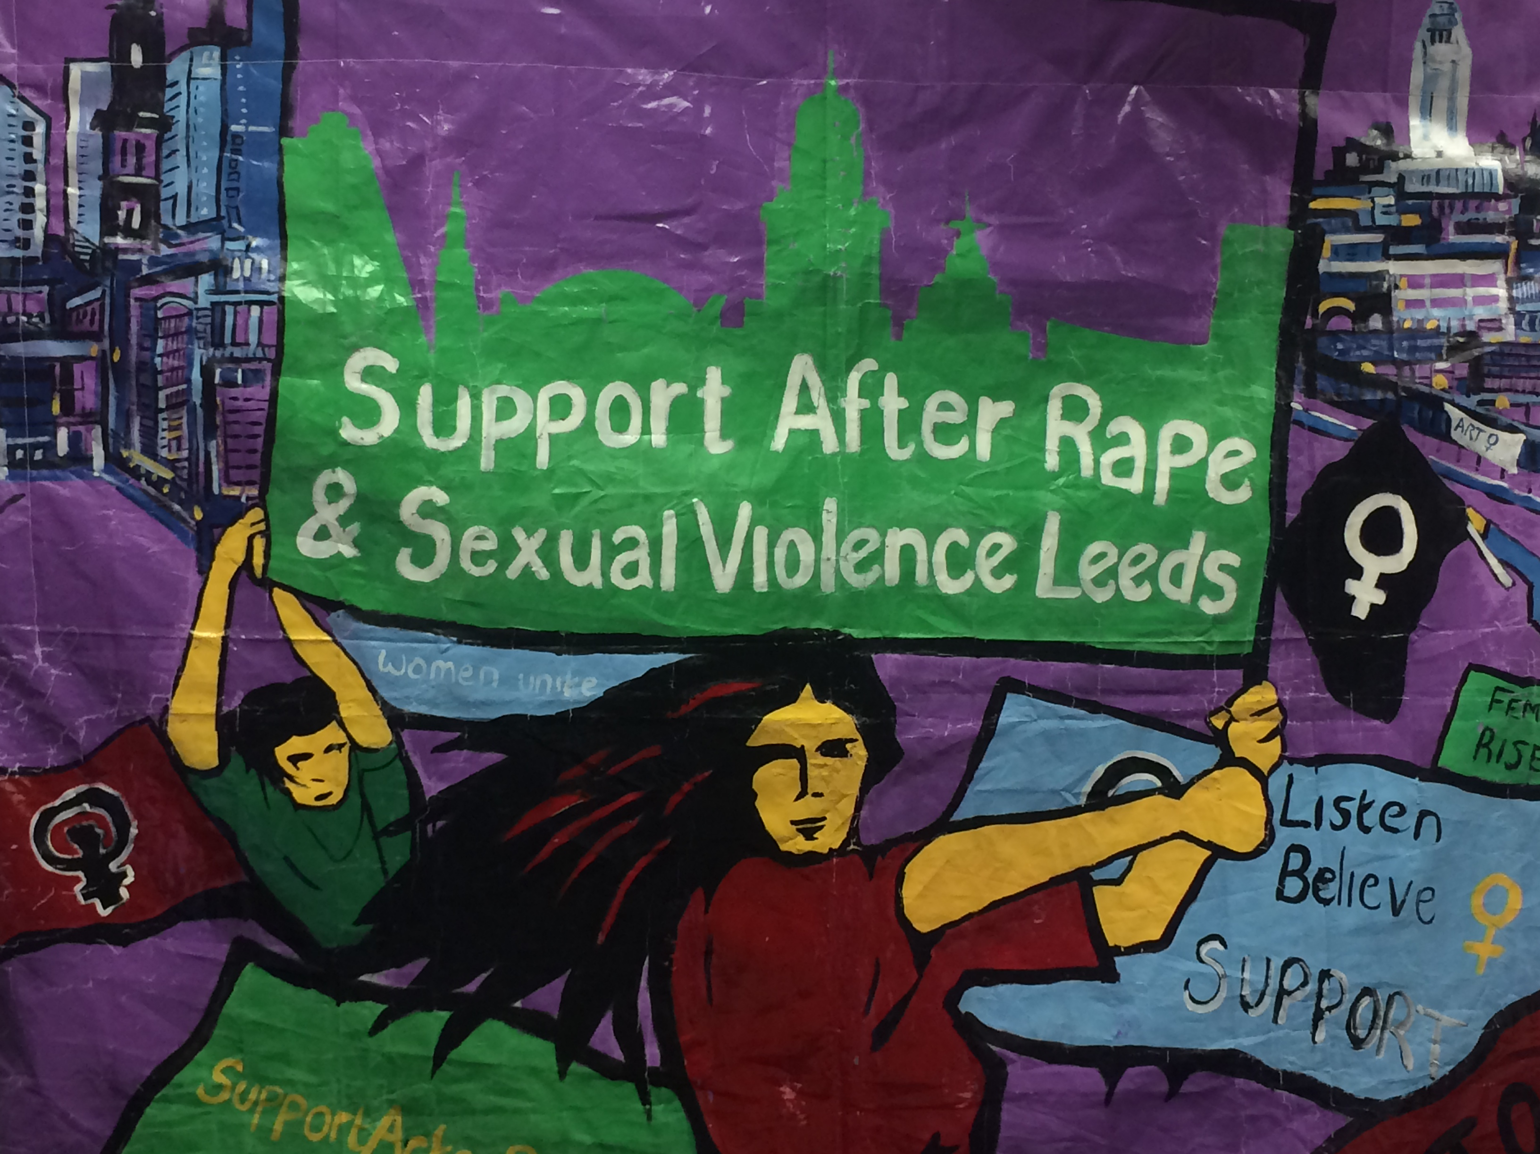
Challenging and Abusive Behaviour
We understand the reasons why some survivors of violence and abuse may present with challenging behaviour. At the same time we have a responsibility to ensure the safety of staff, volunteers and other women, and to maintain appropriate boundaries within support work.
If your behaviour is abusive, we will explore with you what we feel you need to do to make your behaviour acceptable. Wherever possible we will respond to your needs and feelings, and will do what we reasonably can to be able to continue to offer you support. If your behaviour continues to be unacceptable we may withdraw the ISVA Service from you and will communicate with you why we have taken that decision. A further appointment for support will be offered as appropriate.
If your behaviour leads us to decide that we can no longer offer you a service, if you so wish we will work with you to do what we reasonably can to identify an alternative source of support.
Gifts
From our experience of support work we know that women may wish to give small gifts to their ISVA. While we understand that this can be a way of saying ‘thank you’ for the service, our ISVAs are unable to accept any personal gifts or payments from women.

Our Commitment to You
We are fully committed to providing a respectful and accessible service to women who are survivors of sexual violence. In order to deliver this service we will:
- Respect your confidentiality in line with our policy
- Value you as a person and treat you with respect
- Not blame you for the sexual violence you have experienced nor judge you because of the behaviour of an abuser or as a result of abuse within your family
- Agree with you what support we can offer
- Be on time for arranged appointments
- Offer you uninterrupted time
- Respect your boundaries
We ask that you will:
- Be respectful of any staff or volunteer that you come into contact with while receiving support at SARSVL
- Keep to the ISVA Service Support Agreement
- Let us know if you cannot attend an appointment
- Be on time for arranged appointments
- Not attend appointments if you are under the influence of drugs or alcohol

Frequently Asked Questions
Is there a minimum or maximum time that I have to be a SARSVL service user? If you are going through the criminal justice system, we offer you support throughout the process but it always your choice if you wish to engage with us. We can also offer support after the criminal justice process is finished provided you still have advocacy and/or practical support needs. If you are not engaged in the Criminal Justice System and do not wish to be, we can offer you support for a limited period of three months.
Do I have to report to the police to access your service? No, it is entirely up you if you wish to report to the Police and we can provide information about this process. We will respect whatever decision you make about whether to report or not.
Can I access the Advocacy Service if I am already engaged with another agency/other agencies? If you feel that we are the right service to offer you ISVA support you can access our Advocacy Service regardless of whether you are engaged in other services.
If my case is being handled by another Police force, can SARSVL still help me? Our ISVAs can support women and girls living in/around Leeds, regardless of which Police force is handling your case. In the event of your case proceeding to a trial outside West Yorkshire we will do our best to refer you to a local ISVA service for support at trial.
What if I want to become a volunteer? We encourage our service users to become involved with SARSVL if they would like to do so. Service users can apply to volunteer with us one year after leaving our Service.
Feedback
Your feedback, whether positive or negative, is very important to us as it helps us to develop and evaluate our Services to ensure that we provide you and other service users with the best possible support. Your ISVA will collect feedback from you throughout your time in the service to continually monitor your progress as well as the Service that we are delivering to you. If you want to provide further feedback, you can:
- Email feedback@sarsvl.org.uk
- Write to us at PO Box 827, Leeds, LS1 9PN
If you wish to submit a complaint, you can download the complaints form from our website and see more about the complaints process: supportafterrapeleeds.org.uk/contact/complaints/

SARSVL Key Policies
The work of SARSVL is underpinned by a range of policies that have been developed for the protection of our service users and the organisation. There are certain key policies around our service delivery:
Child Protection Policy - We are fully committed to safeguarding and promoting the welfare of children and young people. We recognise our responsibility to take all reasonable steps to promote safe practice and to protect children from neglect, harm, abuse and exploitation. We acknowledge our duty to act appropriately when responding to reports or suspicions that cause concern for the protection, welfare or safety of a child or young person.
Safeguarding Adults Policy - We are fully committed to safeguarding and promoting the welfare of adults at risk and in need of safeguarding. We recognise our responsibility to take all reasonable steps to promote safe practice. We acknowledge our duty to act appropriately when responding to reports or suspicions that cause concern for the protection, welfare or safety of an adult at risk and in need of safeguarding.
Complaints Policy - We are committed to providing the best possible service to the individuals we work with. We acknowledge, however, that there will be occasions when people might not be happy with some aspect of our service provision. Our complaints policy is intended to make it easier for you to tell us when you are dissatisfied with the service you receive from us. All complaints will be taken seriously and we aim to treat you with respect and consideration throughout the complaints process.
Service User Confidentiality Policy - We recognise that confidentiality is of fundamental importance to service users and also essential to the effective running of our whole service. Our Service User Confidentiality Policy is based on the principle that the service user’s interests, wishes and rights are paramount.
Data Security Policy - We collect and use information about the women we support. The policy statement sets out how SARSVL acquires, records, stores discloses and destroys data in line with GDPR. We record details about the sexual offences committed against service users in the advocacy service, where we have knowledge of them. This is for the purposes of internal monitoring and evaluation, providing a service and meeting service user needs as well as funders’ requirements. SARSVL shares statistical information in an anonymised format for the purposes of applying for funding, monitoring how funds are spent and responding to requests for information from Government offices, the Charity Commission and other reputable organisations. Such statistical and anonymised information may also be used for campaigning or publicity purposes.
Professional Boundaries Policy - Providing our staff and volunteers with guidance relating to the setting and maintaining of professional boundaries with service users.
Service User Involvement Policy - This policy clarifies the methods SARSVL uses to involve service users in organisational decision making, and sets out guidelines for service users who wish to volunteer or work with SARSVL in the future.

Equality and Inclusion Policy - We are committed to promoting equality and valuing diversity, which are central to our work. Everyone at SARSVL is committed to ensuring that they abide by this policy. The purpose of the policy is to provide equality and fairness for all in our employment and service delivery. We will not discriminate unlawfully or unfairly because of age, disability, gender identity, marriage and civil partnership, pregnancy and maternity, race, ethnic origin, nationality, national origin, religion or belief, and sexual orientation. Everyone who has contact with the Centre is entitled to experience an environment that promotes dignity and respect for all. We will not tolerate any form of intimidation, bullying or harassment.
If you want to see any of these or any other SARSVL Policy in full, please ask your ISVA.
“My ISVA offered fantastic, invaluable and unforgettable support. Without this I dread to think what could’ve happened to me. I felt safe, secure and comfortable in her presence. I had space to talk about everything I’d been through, I could openly cry and there was no judgement whatsoever. My ISVA attended court with me which made me feel stronger and was the first face I saw after giving evidence. This made me feel believed at a time where I didn’t feel like anyone did.”

Further reading

Rape Crisis England and Wales: If you have just been raped: https://rapecrisis.org.uk/get-help/not-sure-where-to-start/it-happened-recently/

Rape Crisis England and Wales: If you are reporting to the police: https://rapecrisis.org.uk/get-help/looking-for-information/reporting-to-the-police/what-happens-if-i-report/

Rape Crisis England and Wales: Supporting a Survivor: https://rapecrisis.org.uk/get-help/looking-for-information/supporting-a-survivor/

Rape Crisis England and Wales: What is Sexual Violence?: https://rapecrisis.org.uk/get-help/looking-for-information/what-is-sexual-violence/

Rape Crisis England and Wales: Myths vs realities: https://rapecrisis.org.uk/get-informed/about-sexual-violence/myths-vs-realities/

Rape Crisis South London: #BreaktheSilence: https://rapecrisis.org.uk/get-informed/about-sexual-violence/myths-vs-realities/

West Yorkshire Police: Sexual Assault: https://www.westyorkshire.police.uk/staysafe

Rights of Women: From Report to Court: https://rightsofwomen.org.uk/get-information/criminal-law/report-court-handbook-adult-survivors-sexual-violence/

Rape Crisis Scotland: Rape and Sexual Assault Abroad: https://www.rapecrisisscotland.org.uk/publications/RCShelplineOSleaf-0814-AW.pdf

Nina Burrowes: The Courage to be me: https://ninaburrowes.com/books/the-courage-to-be-me/

Nina Burrowes: Sexual Abuse and the questions you’ve never had a chance to ask: https://ninaburrowes.com/sexual-abuse-the-questions-youve-never-had-the-chance-to-ask/

Rape Crisis Scotland: Resources for Survivors: https://www.rapecrisisscotland.org.uk/publications/?cat=9

Useful numbers

SARSVL Helpline: www.supportafterrapeleeds.org.uk/services/helpline
Phone: 0808 802 3344 / Text: 07860022880 / Email: support@sarsvl.org.uk
RCEW Helpline
Phone: 0808 802 9999 / Webchat: https://rapecrisis.org.uk/get-help/want-to-talk/
Police: In case of immediate danger please call 999. For non-emergency calls please call 101.
Domestic Violence
Behind Closed Doors 24 Hour Helpline 0113 246 0401 / https://www.behind-closed-doors.org.uk/
Behind Closed Doors delivers the LDVS Outreach service, offering face-to-face community based support and advocacy to reduce risk, increase safety, access civil legal help and manage practical needs. Their PARS service supports people who have experienced DV but are not considered to be at high risk.
Leeds Domestic Violence Service (LDVS) 24 Hour Helpline 0113 246 0401 / https://ldvs.uk/
Confidential advice and support for women and men experiencing domestic violence and abuse and women seeking refuge. They also provide IDVA services for people experiencing domestic violence and/or reporting to the Police.
Leeds Women’s Aid 24 Hour Helpline 0113 246 0401 / https://leedswomensaid.co.uk/
Leeds Women’s Aid provides various drop-ins and support groups, additional shared refuge accommodation, the Staying Safe group ‘Healthy Relationships’ programme, and support and accommodation for women who have been trafficked.
National Domestic Violence 24 hour Helpline 0808 2000 247 / https://www.nationaldahelpline.org.uk/
A national service providing emotional and practical support for women experiencing domestic violence and abuse, their family, friends, colleagues and others calling on their behalf.
National Jewish Women’s Aid Helpline 0808 801 0500 (DV) 0808 801 0656 (SV) / http://www.jwa.org.uk
Support for Jewish women and men experiencing domestic and/or sexual violence.
National Centre for Domestic Violence 0800 970 2070 / https://www.ncdv.org.uk/
Provides a free, fast emergency low cost injunction service to survivors of domestic violence and abuse regardless of their financial circumstances.
Forced Marriage Unit 0207 008 0151 / www.gov.uk/forced-marriage
If you are worried you might be forced into marriage, or are worried about a friend or relative give them a call.
Karma Nirvana 0800 5999 247 / www.karmanirvana.org.uk
An organisation supporting victims and survivors of forced marriage and honour based violence through their Helpline and Advocacy services.
Housing
Leeds Housing Options 0113 222 4412 / www.leeds.gov.uk/housing/homeless-or-at-risk/contact-leeds-housing-options
Help and advice on housing, including emergency accommodation for women and men experiencing violence, whether council or private tenants or owner-occupiers.
Engage Leeds 0113 380 7615 / www.engageleeds.org.uk
Housing support and options for anyone living in Leeds.
Social Services
Information for people who need extra support to access services and feel safe living in Leeds.
Leeds Adult Social care 0113 222 4401 / leeds.gov.uk/residents/health-and-social-care/adult-social-care
Child Social Services 0113 222 4403 / leeds.gov.uk/residents/health-and-social-care/keeping-children-safe
Sex Worker Support
Basis Yorkshire 0113 243 0036 / basisyorkshire.org.uk/
Service supporting sex working women, and young people (girls, young women and boys) who are being sexually exploited and/or at risk of being sexually exploited.
Joanna Project 0113 350 8071 / joannaproject.co.uk/
Working with women through holistic and ongoing support, working towards a safe life free from sex work and/or drug addiction.
Women’s Organisations
Women’s Health Matters 0113 276 2851 / www.womenshealthmatters.org.uk/
Working with women who have unequal access to health and support services to improve their quality of life through group work, peer support and one to one sessions.
Together Women Project 0113 380 8900 / www.togetherwomen.org/
Working to support women and girls with multiple and complex needs through one to one and group work in their women-only spaces.
For parents
PACE 0113 240 3040 (office); 0113 240 5226 (helpline) / www.paceuk.info
Parents Against Child Exploitation (PACE) works alongside parents and carers of children who are – or are at risk of being – sexually exploited by perpetrators external to the family.
MOSAC 0800 980 1958 / mosac.org.uk/
Help for all non-abusing parents and carers whose children have been sexually abused.
Alcohol and Drug Services
Forward Leeds 0113 887 2477 / www.forwardleeds.co.uk
The alcohol and drug service in Leeds for adults, young people and families through group work, harm reduction work and one to one work.
Mental Health Services
Touchstone 0113 271 8277 / www.touchstonesupport.org.uk/
Providing mental health and wellbeing services to people living in Leeds, working on an individual basis as well as working across communities.
Mind 0113 305 5800 / www.leedsmind.org.uk
Promoting positive mental health and wellbeing by supporting those who need it through counselling, group work, social and peer support, housing and employment support, and suicide bereavement support.
Leeds Survivor-Led Crisis Service 0808 800 1212 (helpline); 0113 260 9328 (Dial House) / www.lslcs.org.uk/
A mental health charity providing out-of-hours support to people in acute mental health crisis though person-centred helpline and drop-in support.
Self-harm and Suicide
Samaritans 116 123 / www.samaritans.org
24 hour helpline for anyone going through difficulties and wanting someone to talk to.
Papyrus 0800 068 4141 / www.papyrus-uk.org/
A charity providing confidential support and advice to young people struggling with thoughts of suicide.
Battle Scars 07410380747 / www.battle-scars-self-harm.org.uk/
Support group and services for anybody affected by self-harm to break down stigma and help people struggling to feel less alone.
Stalking
National Stalking Helpline 0808 802 0300 / www.suzylamplugh.org/pages/category/national-stalking-helpline
Help and advice if you are being stalked or concerned about being stalked.
LGBTQ+
LGBT+ Switchboard 0300 330 0630 / switchboard.lgbt/
Helpline for LGBTQ+ people.
Galop 0800 999 5428 / www.galop.org.uk/
A specialist LGBT+ anti-violence charity providing advice, support and advocacy to LGBT people who have experienced hate crimes, domestic abuse, and/or sexual violence.
Children
Childline 0800 1111 / www.childline.org.uk/
Free, 24 hour confidential helpline for children and young people who need to talk. Trained counsellors are there to provide comfort, support and advice on any problems.
NSPCC 0808 810 800/ www.nspcc.org.uk/
Working to protect children and prevent abuse, and providing support to children living in abusive situations.

June 2020

