Volunteer Counsellor Application Form
Data Protection
We will keep the information you provide us with for reviewing your suitability for volunteering position and nothing else. If we won’t be able to offer you the role of Volunteer Counsellor after 6 months the information you have provided will be securely shredded.
Contact details:

Name:
Address:
Postcode:
E-mail:
Telephone (daytime):
Telephone (evening):
Preferred method of contact (if applicable):

References:
Please give the details of two people who can provide references for you. One of these should be a current or previous employer or your course tutor and one should be your current or most recent clinical supervisor. If this is inappropriate or not possible, please explain why and provide alternative reference(s).

1. Name: | 2. Name:
Address: | Address:
Postcode: | Postcode:
E-mail: | E-mail:
Telephone (day): | Telephone (day):
Telephone (evening): | Telephone (evening):
How do you know this person? | How do you know this person?
May we contact this person before appointment? | May we contact this person before appointment?

Membership:

SARSVL is a BACP member.
Please provide a membership of Counselling/Psychotherapy Organisation(s).
Name: | Status: | Number:
.

Experience of providing Counselling.
To be considered for this role you would need to complete 100 hours of supervised face to face counselling hours.

Please, let us know how many hours have you completed of supervised face to face sessions?

Education, training and qualifications.
Please include any relevant additional training

School/college/institution | Dates from & to | Course attended and/or qualification gained

Previous Employment and Volunteering

Please list previous and current, voluntary and paid counselling experience and include any relevant paid or unpaid work, starting with the most recent.

Employer | Post held | Dates |  | Main duties
 |  | From: | To:

Information in support of your application:
Use this space to provide any information relevant to your application. Please take care to refer to the commitments specified in SARSVL Volunteer Counsellor Role Description to tell us about your relevant experience, knowledge, skills and attributes, using examples wherever possible. You may continue on additional sheets if required but please ensure your answer to this question is no longer than four A4 sides in total, in no smaller than pt. 12 font size.

Reasonable adjustments:
The selection process consists of this form and an informal interview. Do you need any adjustments to be able to participate in this process? If so, please specify:

Criminal offences and safeguarding children and vulnerable adults

The position you have applied for is exempt from the Rehabilitation of Offenders Act 1974 and is subject to a Disclosure and Barring Service (DBS) check. This means that you should provide information about all previous convictions, including those that are spent. Failure to disclose relevant information below could lead to Support After Rape & Sexual Violence Leeds (SARSVL) withdrawing an offer of employment.

The information you provide here will be kept confidential.
The disclosure of a criminal record will not necessarily prevent your employment with SARSVL. In making a decision, we will carefully consider any conviction’s relevance to the appointment.

Have you at any time been convicted of a criminal offence? Yes / No

Have you been restricted from working with children or vulnerable adults? Yes / No

If the answer to either or both of these questions is ‘yes’, please give details:

Sheet 1 and Sheet 2 will be detached before your application form is submitted to the short-listing panel.

*Please sign the declaration in order to complete your application*

Declaration:

I confirm that all of the information I have provided on this form is correct to the best of my knowledge. I understand that, if I am appointed to this post and it is subsequently discovered that I have willfully or neglectfully given false information, I may be liable to instant dismissal.

Signature: Date:

Please note: An electronic signature is acceptable.

Finally, if you are happy to, please tell us where you found out about this vacancy. This information is for our internal use only and will help us with future recruitments:

Return this application form via e-mail to katiewhitehouse@sarsvl.org.uk

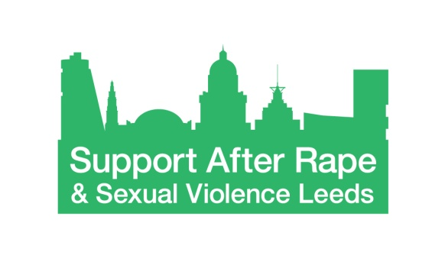
Equality and Diversity Monitoring Form

Support After Rape & Sexual Violence Leeds (SARSVL) is committed to equality and to actively seeking qualified candidates that contribute to the diversity of the organisation.

We are asking for the following information so that we can monitor and ensure that our recruitment and selection processes are free from bias and discrimination. The data we are asking for reflects the Equality Act 2010 requirement not to discriminate on the grounds of age, disability, ethnicity, marital/civil partnership status, religion or belief, sexual orientation and pregnancy and childbirth.

The information you provide will be treated confidentially within SARSVL. We detach this information from your application form before your application form is forwarded for consideration; the information you provide will not be used to make any decisions affecting you.

Thank you for completing this form.

Age
What is your age group?

16 – 25 26 – 35 36 – 45 46 – 55 56 – 65 66+

Prefer not to say

Disability
The Equality Act 2010 defines disability as:
“A physical or mental impairment which has a substantial and long-term adverse effect on a person's ability to carry out normal day-to-day activities.”
Do you consider yourself to be a disabled person?

Yes No Prefer not to say

Ethnicity

How would you describe your ethnicity?
Please choose one section from A to F and then tick the appropriate box.
A. White
English, Welsh, Scottish, Northern Irish, British
Irish
Gypsy or Irish Traveller
White other
B. Mixed / Multiple ethnic groups
White and Black Caribbean
White and Black African
White and Asian
Any other Mixed background
C. Asian or Asian British
Indian
Bangladeshi
Pakistani
Chinese
Any other Asian background
D. Black / African / Caribbean / Black British
Caribbean
African
Any other Black background
E. Other ethnic group
Arab
Any other ethnic background
F. Prefer not to say

Gender identity
Is your gender identity the same as the gender you were assigned at birth?
Yes No Prefer not to say

Marital / Civil Partnership status
Are you married or in a civil partnership?
Yes No Prefer not to say

Religion and belief
Buddhist
Christian
Hindu
Muslim
Jewish
Sikh
Other Religion or Belief
No Religion
Prefer not to say

Sexual orientation
Please state your sexual orientation
Prefer not to say

