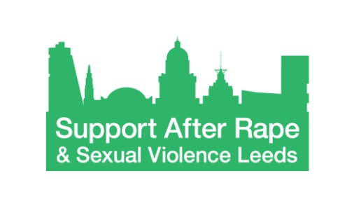
April 2020

Re. Senior Counsellor
Dear Applicant,
Thank you for contacting us and for your interest in working for SARSVL.
Please find enclosed a full application pack for the post about which you’ve enquired, including:
- Job Description and Person Specification
- Background Information for Applicants
- Application Form
- Equality & Diversity monitoring form
For further information about SARSVL, you can visit www.supportafterrapeleeds.org.uk.
Please return your completed application by e-mail to info@sarsvl.org.uk before the deadline of noon on the 12th June 2020. Please be aware that applications received after the deadline unfortunately cannot be considered.
Please note that it is an occupational requirement under the Equality Act 2010 (Schedule 9, part 1) for this post to be filled only by a woman.
If your application is short-listed, we will be in touch to invite you to interview. Interviews will take virtually on 1st June 2020. Please keep this date free as it will not be possible to offer an alternative interview date.
If you have not heard from us by close of business on the 29th May 2020, please assume that you have not been short-listed on this occasion.
Yours sincerely,

Rebecca Burton

Senior HR & Financial management
On behalf of Support After Rape & Sexual Violence Leeds (SARSVL)

