Support After Rape and Sexual Violence Leeds (SARSVL)
Volunteer Counsellor Application Form

Your Contact Details:

Full Name: |  | Phone Number:
Address: |  | Daytime:
Postcode: |  | Mobile:
Email:
Do you have any previous criminal convictions?  Having convictions is not necessarily a barrier to volunteering, however we will carry out an enhanced DBS check and will ask you about any convictions. This includes ‘spent’ convictions. |  |  | Yes |  | No
Do you have any access requirements (e.g. large print, wheelchair access, induction loop etc) |  |  | Yes |  | No
If you have answered 'yes' to the above question about access requirements, we will contact you to discuss your needs.
Please give us details of all your counselling or psychotherapy training. You must give the full name of the institution and the dates of your enrolment and completion.
Please give details of other relevant training.
Please give full details of your counselling experience.
Please tell us about your previous experiences of volunteering.
Please give details of other experience that could be relevant to your application.
Please tell us why you decided to apply to volunteer for a feminist organisation.
Are you currently employed? What is your occupation?
How did you learn about SARSVL?

Please provide a supporting statement as to why you would like to join our team of volunteer counsellors. Please address any points in the volunteer role description that have not been addressed above.
Do you already know a woman who volunteers or works for SARSVL? | Yes |  | No
If you replied ‘yes’ above, please give us her name below. We will speak to her about the fact that you have applied, but will not share any information about your application.
SARSVL woman’s name:

Please supply the names of two referees. One of your referees must be your counselling course tutor or a clinical supervisor. Referees must be able to comment on your suitability for the role. Please do not include people who are related to you.
Name: |  | Name:
JobTitle (if relevant): |  | JobTitle (if relevant):
Phone Number (Day): |  | Phone Number (Day):
Email: |  | Email:
Capacity in which you know this referee: |  | Capacity in which you know this referee:

Statement:
I declare that all the information in this application is, to the best of my knowledge, correct.
Your name: |  | Date:
Signature:
THANK YOU
Return your form to us by email to erene@sarsvl.org.uk or by post to PO Box 827, Leeds LS1 9PN. Your form must reach us no later than noon on Friday 12th August 2016. Applications received after this deadline will not be considered.

Please take a moment to complete the Equality & Diversity Monitoring Form overleaf, which will be detached before this application form is assessed.

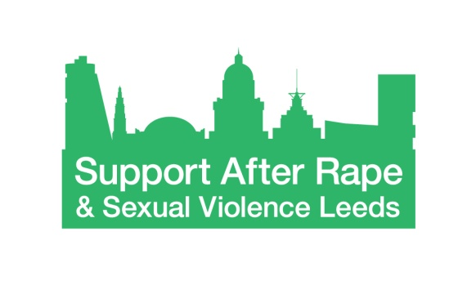
Equality and Diversity Monitoring Form

Support After Rape & Sexual Violence Leeds (SARSVL) is committed to equality and to actively seeking qualified candidates that contribute to the diversity of the organisation.

We are asking for the following information so that we can monitor and ensure that our recruitment and selection processes are free from bias and discrimination. The data we are asking for reflects the Equality Act 2010 requirement not to discriminate on the grounds of age, disability, ethnicity, gender identity, marital/civil partnership status, religion or belief, sexual orientation and pregnancy and childbirth.

The information you provide will be treated confidentially within SARSVL. We detach this information from your application form before your application form is forwarded for consideration; the information you provide will not be used to make any decisions affecting you.

Thank you for completing this form.

Age
What is your age group?

16 – 25 26 – 35 36 – 45 46 – 55 56 – 65 66+

Prefer not to say

Disability
The Equality Act 2010 defines disability as:
“A physical or mental impairment which has a substantial and long-term adverse effect on a person's ability to carry out normal day-to-day activities.”
Do you consider yourself to be a disabled person?

Yes No Prefer not to say

Ethnicity

How would you describe your ethnicity?
Please choose one section from A to F and then tick the appropriate box.
A. White
English, Welsh, Scottish, Northern Irish, British
Irish
Gypsy or Irish Traveller
White other
B. Mixed / Multiple ethnic groups
White and Black Caribbean
White and Black African
White and Asian
Any other Mixed background
C. Asian or Asian British
Indian
Bangladeshi
Pakistani
Chinese
Any other Asian background
D. Black / African / Caribbean / Black British
Caribbean
African
Any other Black background
E. Other ethnic group
Arab
Any other ethnic background
F. Prefer not to say

Gender identity
Is your gender identity the same as the gender you were assigned at birth?
Yes No Prefer not to say

Marital / Civil Partnership status
Are you married or in a civil partnership?
Yes No Prefer not to say

Religion and belief
Buddhist
Christian
Hindu
Muslim
Jewish
Sikh
Other Religion or Belief
No Religion
Prefer not to say

Sexual orientation
Please state your sexual orientation
Prefer not to say

