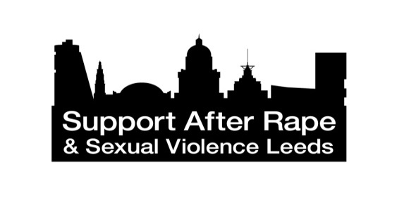
Advocacy @ SARSVL
Tuesday 31st March 18.30 – 20.00
Quaker Meeting House
188 Woodhouse Lane
Leeds LS2 9DX
Information Session Booking Form
SARSVL invite you to come and meet us, to hear more about the new Advocacy Service we are developing, and the opportunities available to get involved.
Please complete and return this form via email to cath@sarsvl.org.uk or email the information required below, or simply call 0113 243 9102 and leave the same information.
Before Friday 27th March.
Name

Address

Contact tel.

Email

Any access or other special requirements?
Please give details
(e.g. we are able to provide written information in larger print)

Please state whether your interest is in volunteering / general service information

If you aren’t able to attend on 30th March, but would like more information please tick the box that applies below
More about volunteering with us
More about the Advocacy service, and how to make referrals / signpost to us in future

Thank you!
www.SupportAfterRapeLeeds.org.uk

