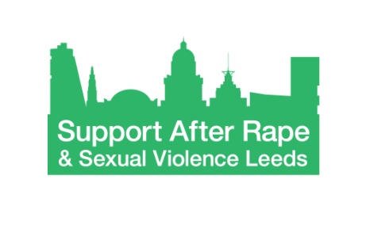
Support After Rape & Sexual Violence Leeds (SARSVL)

Formal Complaints Form

Your name

Your postal address

Postcode

Your phone number

Your e-mail address

Please only provide contact details you are happy for us to use to get in touch with you about your complaint you. Please also let us know if there is a way you would prefer to be contacted e.g. by e-mail or post.:

What is your complaint? Please give as much detail as you can, including dates and names of people involved, if relevant. You can continue on an extra sheet if necessary.

Ideally, what would you like us to do about this issue? Please continue on an extra sheet if necessary.

Your signature

Today’s date
Please put this form in the box provided at the SARSVL Centre, send it to SARSVL at PO Box 827 Leeds LS19PN or email it as an attachment to an email at feedback@sarsvl.org.uk.

Please be aware that we can’t guarantee the security of complaints sent via e-mail.

