Support After Rape and Sexual Violence Leeds (SARSVL)
Service Delivery Volunteer Application Form

Before completing this form please read through the accompanying booklet carefully. The information you provide in your application will be kept confidential.

You must be available to attend all the training dates listed in the accompanying booklet. If you are not able to attend every session we will not be able to consider your application.

Your Contact Details:

Full Name: |  |  |  | Phone Number:
Address: |  |  |  | Daytime:
Postcode: |  |  |  | Mobile:
Email:
Your availability for Helpline Shifts once training is completed:
Please tick all the times you could be available below:
Day |  | Morning | Afternoon |  |  | Evening
Monday
Tuesday
Wednesday
Thursday
Friday
Saturday
Sunday
Do you have any previous criminal convictions?  Having convictions is not a barrier to volunteering, however we will carry out an enhanced DBS check and will ask you about any convictions. This includes ‘spent’ convictions. |  |  |  |  |  |  | Yes |  | No
Do you have any access requirements (large print, wheelchair access, induction loop etc) |  |  |  |  |  |  | Yes |  | No
If you have answered yes to the above question about access requirements a trainer will contact you to discuss your needs.
Please tell us about any experience that you have in the following areas. This can be something you have done in your work or personal life, for example supporting a friend or relative. Do not disclose anything you do not feel comfortable with.
Supporting people:

Feminism and Women’s Organisations:

Taking part in training:

Why have you decided to apply to volunteer for the SARSVL helpline rather than another organisation?

Do you already know a woman who volunteers or works for SARSVL? |  |  |  |  | Yes |  |  | No
If you replied ‘yes’ above, please give us her name below. We will speak to her about the fact that you have applied, but will not share any information about your application.
SARSVL woman’s name:

Please supply the names of two referees. Referees do not have to be linked to your employment, but must be able to comment on your suitability for the role. Please do not include people who are related to you.
Name: |  | Name:
JobTitle (if relevant): |  | JobTitle (if relevant):
Phone Number (Day): |  | Phone Number (Day):
Email: |  | Email:
Capacity in which you know this referee: |  | Capacity in which you know this referee:

Statement:

I declare that all the information in this application is, to the best of my knowledge, correct.

I am available to attend all the Training dates, and have read and understood the accompanying information booklet.

Both my referees are aware that SARSVL will be in touch, and are able to supply a reference by the deadline of 28th August 2015.

Your name: |  | Date:
Signature:
THANK YOU
Return your form to us by email to sarsvl.helpline.training@gmail.com or by post to PO Box 827, Leeds LS1 9PN. Your form must reach us no later than 5pm on Friday 14th August 2015. Applications received after this deadline will not be considered.
Please take a moment to complete the Equality & Diversity Monitoring Form overleaf. Which will be detached before this application form is assessed.

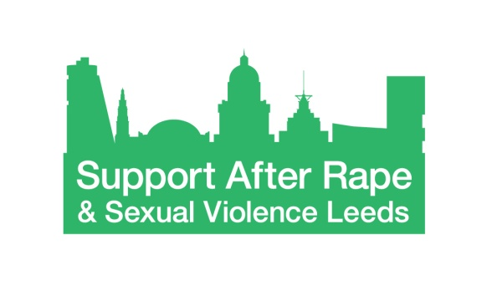
Equality and Diversity Monitoring Form

Support After Rape & Sexual Violence Leeds (SARSVL) is committed to equality and to actively seeking qualified candidates that contribute to the diversity of the organisation.

We are asking for the following information so that we can monitor and ensure that our recruitment and selection processes are free from bias and discrimination. The data we are asking for reflects the Equality Act 2010 requirement not to discriminate on the grounds of age, disability, ethnicity, gender identity, marital/civil partnership status, religion or belief, sexual orientation and pregnancy and childbirth.

The information you provide will be treated confidentially within SARSVL. We detach this information from your application form before your application form is forwarded for consideration, and so the information you provide will not be used to make any decisions affecting you.

Thank you for completing this form.

Age
What is your age group?

16 – 25 26 – 35 36 – 45 46 – 55 56 – 65 66+

Prefer not to say

Disability
The Equality Act 2010 defines disability as:
“A physical or mental impairment which has a substantial and long-term adverse effect on a person's ability to carry out normal day-to-day activities.”
Do you consider yourself to be a disabled person?

Yes No Prefer not to say

Ethnicity

How would you describe your ethnicity?
Please choose one section from A to F and then tick the appropriate box.
A. White
English, Welsh, Scottish, Northern Irish, British
Irish
Gypsy or Irish Traveller
White other
B. Mixed / Multiple ethnic groups
White and Black Caribbean
White and Black African
White and Asian
Any other Mixed background
C. Asian or Asian British
Indian
Bangladeshi
Pakistani
Chinese
Any other Asian background
D. Black / African / Caribbean / Black British
Caribbean
African
Any other Black background
E. Other ethnic group
Arab
Any other ethnic background
F. Prefer not to say

Gender identity
Is your gender identity the same as the gender you were assigned at birth?
Yes No Prefer not to say

Marital / Civil Partnership status
Are you married or in a civil partnership?
Yes No Prefer not to say

Religion and belief
Buddhist
Christian
Hindu
Muslim
Jewish
Sikh
Other Religion or Belief
No Religion
Prefer not to say

Sexual orientation
Please state your sexual orientation
Prefer not to say

